# Database Systems

# CP 2

**Basic :** [**https://www.youtube.com/watch?v=F68eq_AvdbU&list=PLQRkqznnXfkxvkdKLI3lQnGZIjCh6OC1o&index=5**](https://www.youtube.com/watch?v=F68eq_AvdbU&list=PLQRkqznnXfkxvkdKLI3lQnGZIjCh6OC1o&index=5)

**Like :** [**https://www.youtube.com/watch?v=m28VrFIMMzU&list=PLQRkqznnXfkxvkdKLI3lQnGZIjCh6OC1o&index=9**](https://www.youtube.com/watch?v=m28VrFIMMzU&list=PLQRkqznnXfkxvkdKLI3lQnGZIjCh6OC1o&index=9)

**Instructions:**

1. *Submit the PDF/word file on portal.*
2. *It is an individual activity.*
3. **Consider the following relations for a database that keeps track of exams and projects. Create database using the following relational schema. Please define primary and foreign keys as well. Also, take sensible assumption if need (for constraints and data type)**

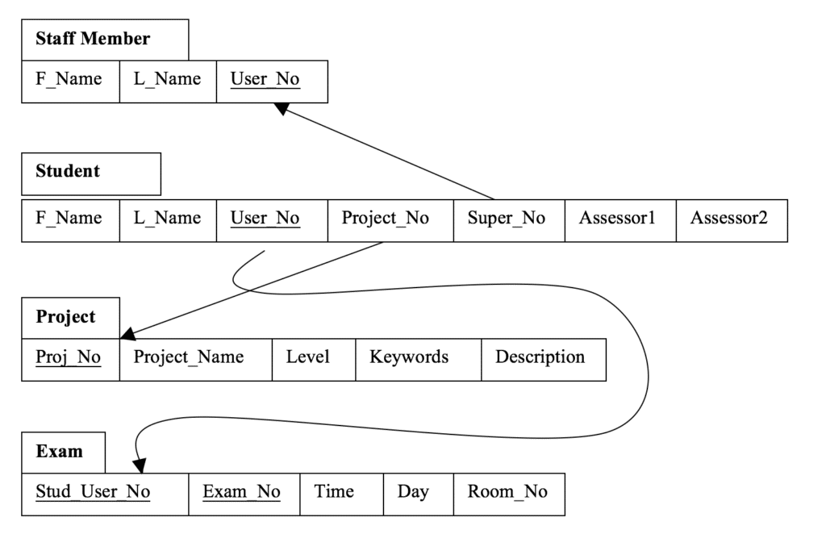

1. **Populate sensible data in the following database. Using Insert statement to insert 5 rows per table. Please make sure that you add data in such way that queries given below will generate some results. (for example for first query result, please add at least one exam in room 005)**
2. **Delete the records of all students who are working on project no 10.**
3. **Change the level of projects from 4 to 5 which have ‘Android’ in their keywords.**
4. **Write query for the following problems**
5. Find exam time and date of student user no: 1010 and Room_no = 005
6. Show all Projects names in ascending order of their names.
7. Show fname of staff member with L_Name stated with A and ends with A and F_name atleast have one A.
8. Show name of student with no supervisor assignment yet. (super_No = NULL)
9. Show user no who are sitting between room 005 and 009 during exam. (use BETWEEN)